Amazon Aurora Overview 🚀
Amazon Aurora is a high-performance, fully managed relational database service provided by AWS. It is compatible with MySQL and PostgreSQL but offers better speed, availability, and scalability than traditional databases.

1️Why Use Amazon Aurora?
✅ 5x Faster than MySQL & 3x Faster than PostgreSQL
✅ Highly Scalable – Supports read replicas & auto-scaling
✅ Fault-Tolerant & Self-Healing – Replicates data 6 times across 3 Availability Zones
✅ Automated Backups & Point-in-Time Recovery
✅ Server less Option Available – Aurora Server less scales automatically
✅ Fully Managed by AWS – No manual patching or maintenance
✅ Cost-Effective – Pay for what you use
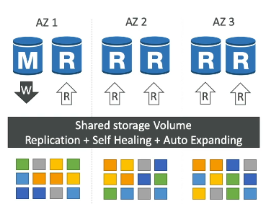

2️Key Features of Amazon Aurora
📌 High Performance – 5x MySQL & 3x PostgreSQL speed
📌 Multi-AZ Replication – Auto-replicates data 6 times across 3 AZs
📌 Auto-Scaling Read Replicas – Up to 15 read replicas for high availability
📌 Aurora Server less – Auto-scales capacity based on workload
📌 Backtrack Feature – Rewind the database up to 72 hours
📌 Global Database – Low-latency read access across multiple AWS Regions

3️How Amazon Aurora Works
Aurora uses a distributed, fault-tolerant storage system that separates compute (EC2) from storage. It automatically scales storage up to 128 TB and replicates data across multiple availability zones for high durability.
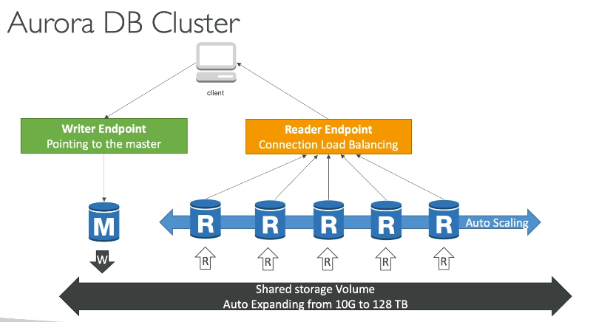

4️Amazon Aurora vs RDS
Feature | Amazon Aurora |  |  |  |  | Amazon RDS
Speed | 5x MySQL, 3x PostgreSQL |  |  |  |  | Standard performance
Replication | 6 copies across 3 AZs |  |  |  |  | Up to 1 standby replica
Scalability | Auto-scales up to 128 TB |  |  |  |  | Requires manual scaling
Read Replicas | Up to 15 replicas |  |  |  |  | Max 5 replicas
Backup & Restore | Point-in-Time Recovery, Backtrack |  |  |  |  | Automated snapshots
Serverless Option | Yes (Aurora Serverless) |  |  |  |  | No

6️Scenario-Based Example
📌 Scenario: High Traffic E-commerce Website
Problem: Your e-commerce website experiences high traffic fluctuations during sales. The database struggles to handle peak traffic, causing slow response times.
Solution: Use Amazon Aurora with Auto-Scaling
✅ Deploy Aurora MySQL/PostgreSQL for high performance2
✅ Use Aurora Read Replicas for read-heavy workloads
✅ Enable Aurora Auto-Scaling to handle peak loads dynamically
✅ Configure Multi-AZ Replication for fault tolerance
✅ Use Aurora Serverless if traffic is highly unpredictable
7 Best Practices for Using Aurora
✅ Use Read Replicas to distribute read traffic
✅ Enable Auto-Scaling for dynamic workloads
✅ Leverage Global Database for multi-region access
✅ Use Backtrack to undo unintentional changes
✅ Monitor with CloudWatch & Performance Insights
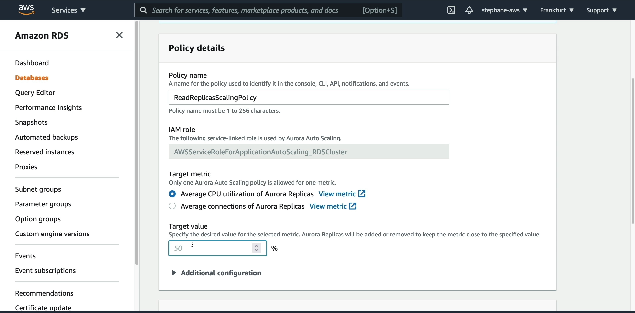
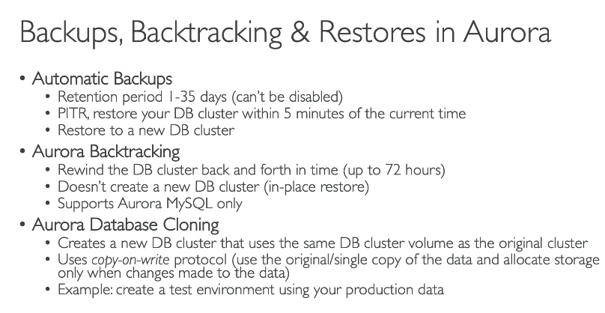
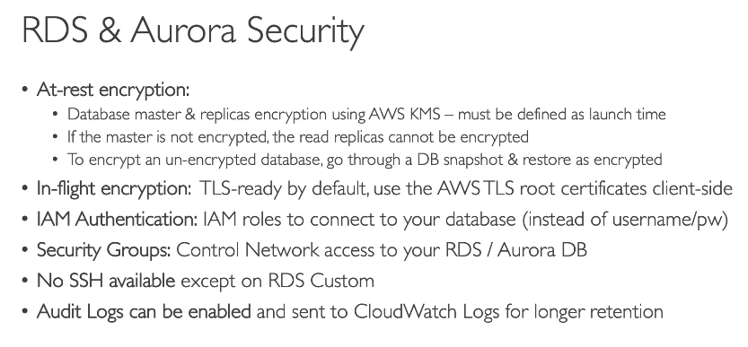

Amazon ElastiCache Overview 🚀
Amazon ElastiCache is a fully managed, in-memory caching service that helps improve application performance by reducing database load and latency. It supports two caching engines: Redis and Memcached.

1️Why Use ElastiCache?
✅ Speeds up database queries by caching frequently accessed data
✅ Reduces database costs by offloading read requests
✅ Scalable & Highly Available – Supports Multi-AZ replication
✅ Fully Managed by AWS – No manual setup or maintenance
✅ Low Latency – Retrieves data in microseconds

2️How ElastiCache Works?
Instead of fetching data from a database every time, applications retrieve frequently used data from ElastiCache, reducing latency and database load.
📌 Example:
- Without Cache: Every user request queries the database (slow, high load).
- With Cache: Frequently accessed data is stored in-memory (fast, low load).

3️ ElastiCache Engines
ElastiCache supports two caching engines:
🔴 Redis (Recommended for Most Use Cases)
✅ Supports data persistence (snapshot & backup)
✅ Multi-AZ replication & failover for high availability
✅ Advanced features like pub/sub messaging, leaderboards, geospatial queries
✅ Encryption & authentication for security
✅ Ideal for real-time analytics, gaming, session storage
🔵 Memcached (Simple Key-Value Cache)
✅ Simple and lightweight caching solution
✅ No persistence or replication (in-memory only)
✅ Best for scaling horizontally with multiple nodes
✅ Ideal for distributed caching, session storage

4️ElastiCache vs RDS
Feature | ElastiCache (Redis/Memcached) | RDS (Relational Database)
Purpose | In-memory caching | Persistent database storage
Speed | Microseconds | Milliseconds
Persistence | Redis: Yes | Yes
Multi-AZ Support | Redis: Yes | Yes
Use Case | Caching, session storage, real-time analytics | Transactional data, complex queries

5️Scenario-Based Example
📌 Scenario: E-commerce Website with High Traffic
Problem: The website experiences slow performance because of high database load from repeated product queries.
Solution: Use ElastiCache for Caching
✅ Deploy Redis ElastiCache to store frequently accessed product data
✅ Reduce database load by serving data from cache instead of RDS
✅ Enable Multi-AZ replication for high availability
✅ Use TTL (Time-to-Live) to refresh cache periodically
📌 Result:
🚀 Faster page loads
📉 Lower database costs
💡 Improved user experience

When an Amazon Aurora DB Cluster fails over, it promotes one of the Read Replicas to be the new primary database. The promotion order is based on failover priority tiers and instance size if multiple Read Replicas are in the same tier.

📌 Given Scenario:
- 5 Read Replicas with the same priority tier (Tier 0)
- Instance types:
  - 2x db.r3.xlarge
  - 2x db.r3.4xlarge
  - 1x db.r4.16xlarge

🔍 How Aurora Chooses a Read Replica for Promotion
When a failover occurs, Aurora follows these rules to promote a new primary:
1️First, Aurora selects the Read Replica with the highest failover priority tier.
- Since all Read Replicas have the same priority (Tier 0), this rule does not apply in this case.
2️Next, Aurora selects the largest instance type among Read Replicas.
- The largest instance is db.r4.16xlarge
- Aurora will promote this instance as the new primary.

If you want to create a test environment that uses the same data from your production Aurora DB Cluster, the most cost-effective approach is to use an Aurora Clone instead of creating a new full-size copy.

